25_Create_a_Spring_Web_Project_using_Maven

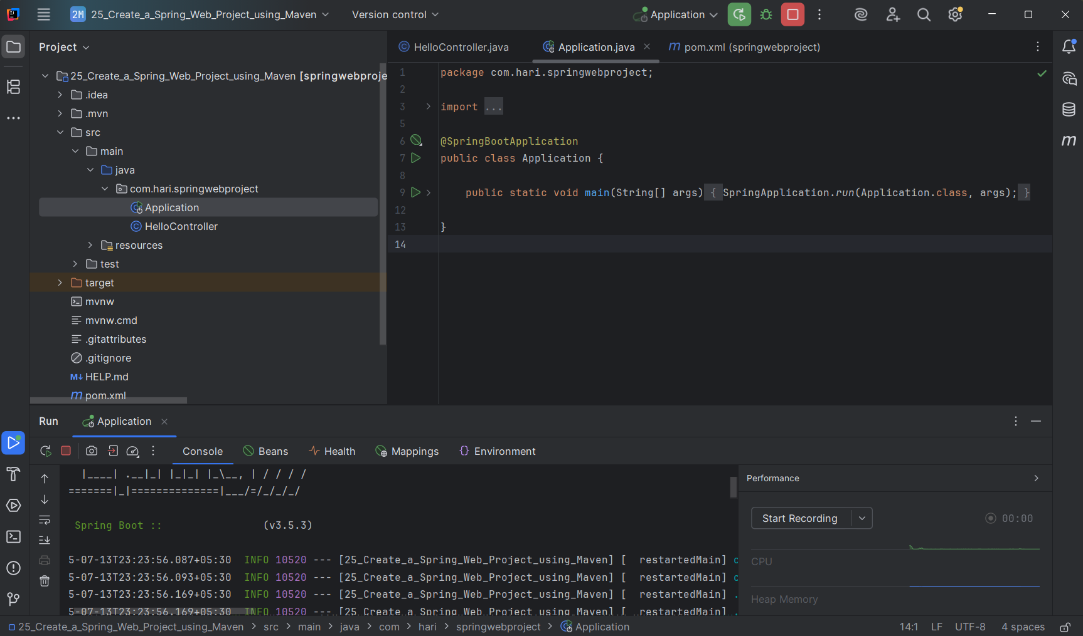

26_Spring Core – Load Country from Spring Configuration XML

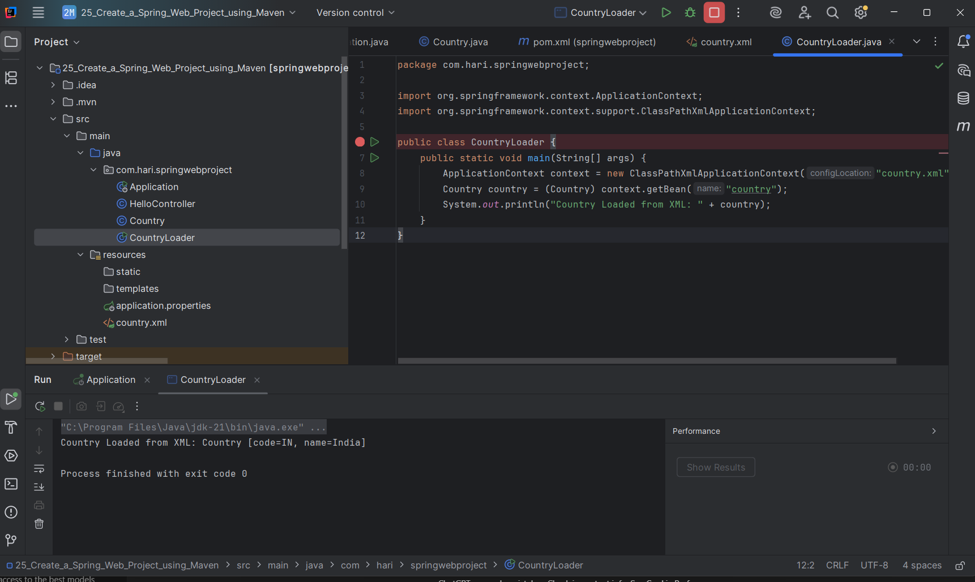

**27_Hello World RESTful Web Service**

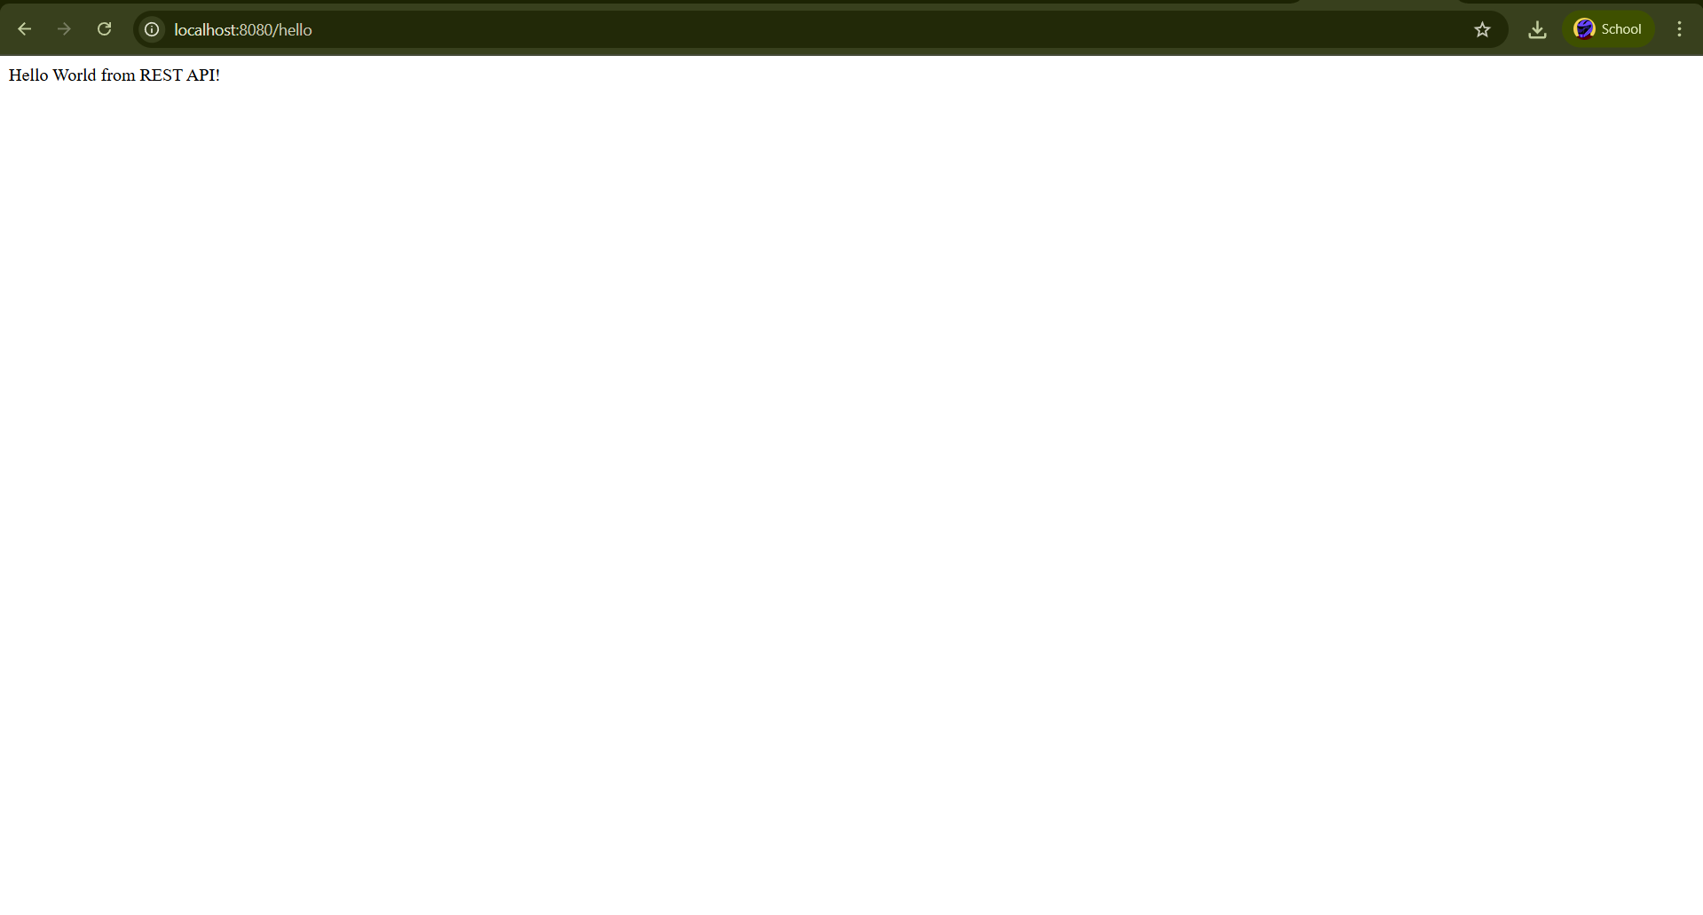

**28_REST - Country Web Service**

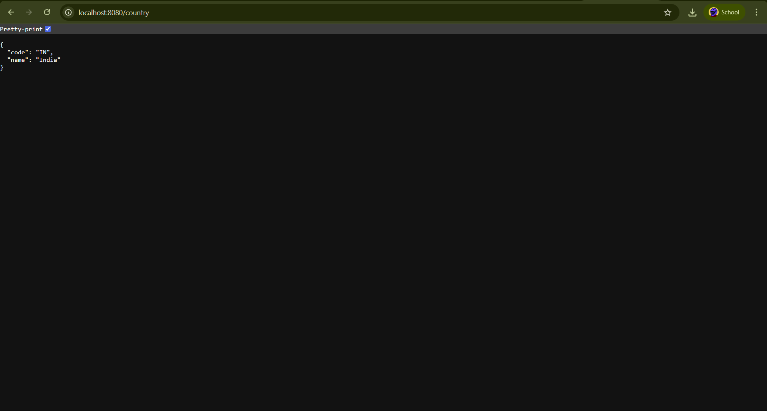

**29_REST - Get country based on country code**

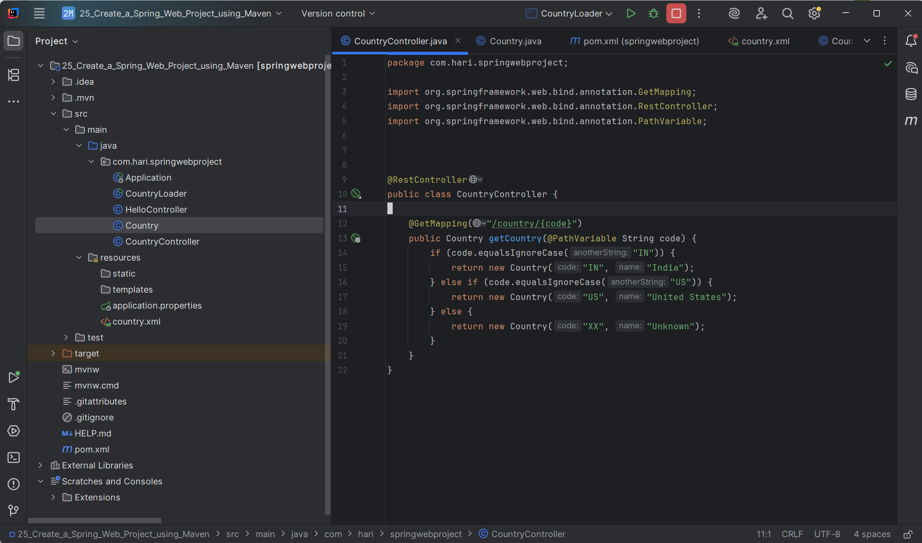

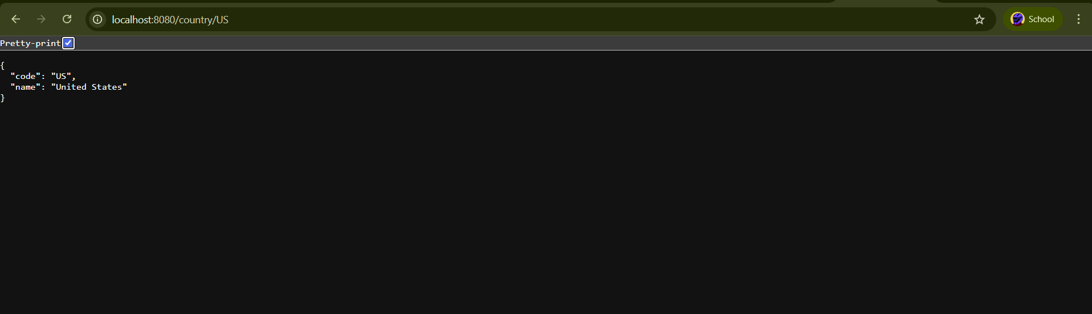

30_Create authentication service that returns JWT

